Capstone Project Report

Customer Segmentation

Name: Revanth Kalluri
Course: AI & ML (Batch-5)
Problem Statement: Perform Customer Segmentation on Online Retail Dataset.

Prerequisites:
Software used and how I installed them:
Python 3.6: Download and install anaconda using https://www.anaconda.com/download/. After installing anaconda, install below modules(packages), using anaconda prompt to run the commands.
Module | Command
numpy | pip install numpy
pandas | pip install pandas
matplotlib | pip install matplotlib
sklearn | pip install scikit-learn
xlrd | pip install xlrd==1.2.0

Pip is a package manager for python packages. Run “pip --version” in anaconda prompt to verify if pip is already installed. Run “conda install pip” to install pip for the first time.

Dataset used:
Online Retail Dataset. Available at - https://archive.ics.uci.edu/ml/datasets/Online%2BRetail

Method used:
RFM Analysis to get Customer specific attributes. KMeans for segmentation.

1. Importing necessary modules:
2. Read Online Retail Dataset:
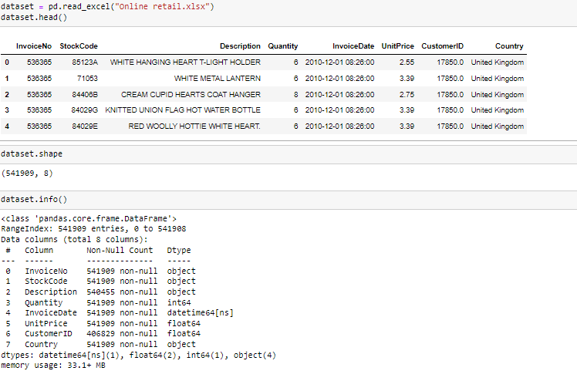

3. Data Pre-Processing:
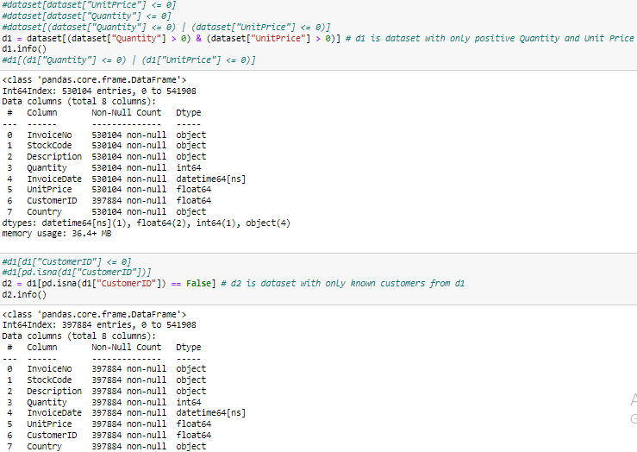
4. Get Total Price per Item:
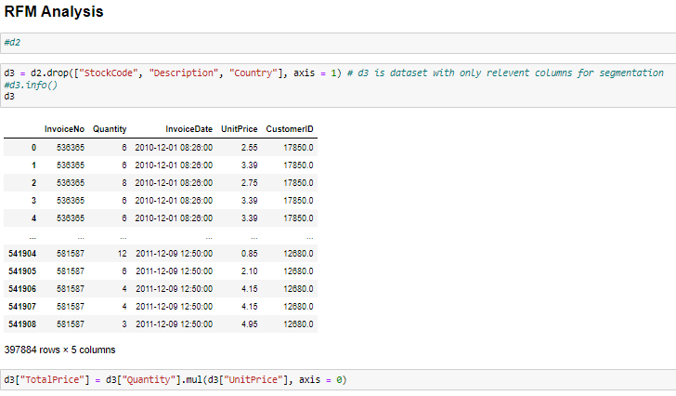
5. Check Recency of each transaction:
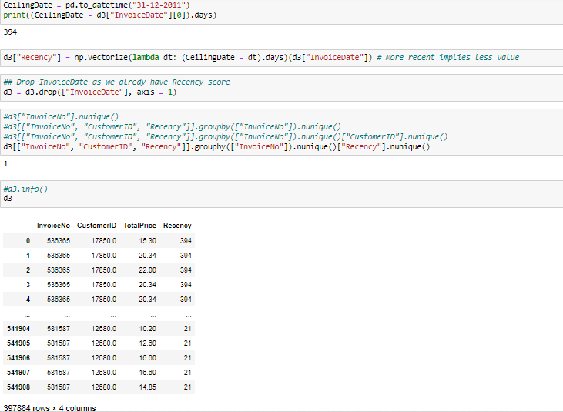
6. Groupby Data based on Customer ID:
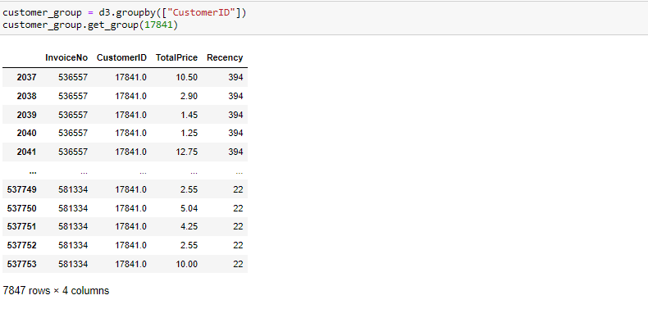

7. Find Customer Recency:
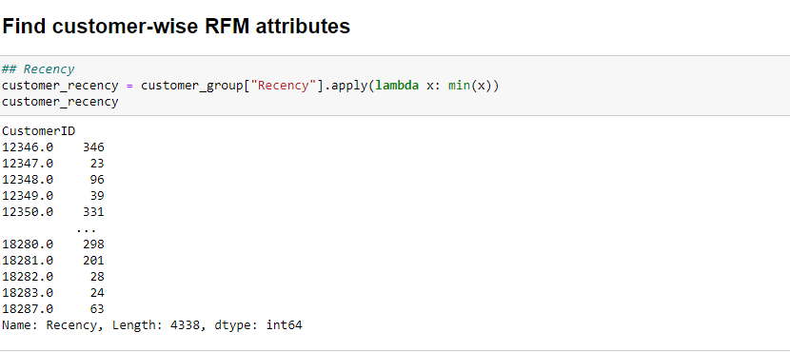
8. Find Customer Frequency:
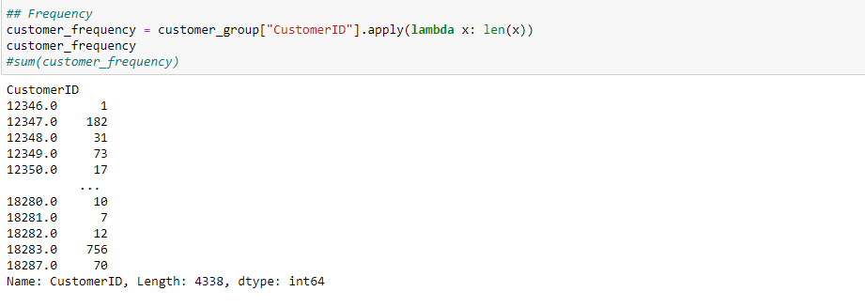
9. Find Customer Monetary:
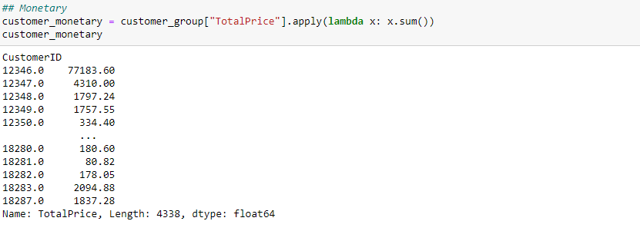

10. Concatenate RFM attributes:
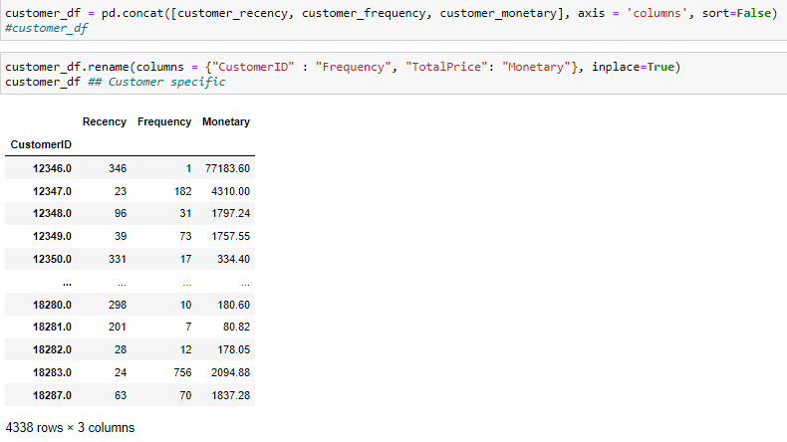
11. Normalize Customer attributes:
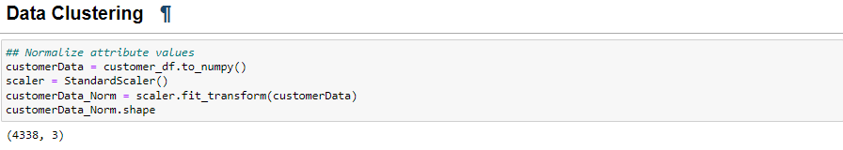
12. Perform KMeans Clustering:
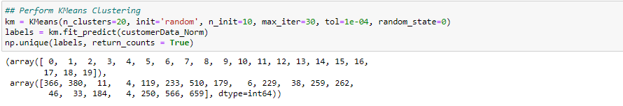

13. Plot clustered data points:
